**Class:** Final Year (Computer Science and Engineering)

**Year:** 2025-26 **Semester:** 1

**Course:** High Performance Computing Lab

**Practical No. 4**

**Exam Seat No: 22510064**

**Github Link:**  [Sem-7-Assign/HPC lab at main · parshwa913/Sem-7-Assign · GitHub](https://github.com/parshwa913/Sem-7-Assign/tree/main/HPC%20lab)

**Title of practical:**

Study and Implementation of Synchronization

**Problem Statement 1:**

# Analyze and implement a Parallel code for below programs using OpenMP considering synchronization requirements. (Demonstrate the use of different clauses and constructs wherever applicable)

# Fibonacci Computation:

#include <stdio.h>

#include <omp.h>

int main() {

    int n, i;

    printf("Enter number of Fibonacci terms: ");

    scanf("%d", &n);

    if (n < 1) {

        printf("Number of terms must be positive.\n");

        return 0;

    }

    long long fib[n];

    fib[0] = 0;

    if (n > 1) fib[1] = 1;

    #pragma omp parallel

    {

        #pragma omp single

        {

            for (i = 2; i < n; i++) {

                #pragma omp critical

                {

                    fib[i] = fib[i - 1] + fib[i - 2];

                }

            }

        }

    }

    printf("Fibonacci Series: ");

    for (i = 0; i < n; i++)

        printf("%lld ", fib[i]);

    printf("\n");

    return 0;

}

**Screenshots:**

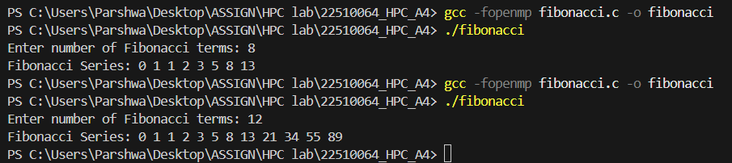

**Information:**

**In parallel programming, synchronization is needed to prevent race conditions when multiple threads update shared data.**

**OpenMP provides synchronization constructs like:**

**#pragma omp critical — ensures only one thread executes the section at a time.**

**#pragma omp barrier — all threads wait until all have reached the barrier.**

**The Fibonacci sequence is computed as:**

**F(0) = 0, F(1) = 1, F(n) = F(n-1) + F(n-2)**

**Since multiple threads may update the shared fib[] array, we use critical sections.**

**Algorithm:**

1. **Accept number of terms n.**
2. **Initialize fib[0] = 0, fib[1] = 1.**
3. **Parallelize loop from i = 2 to n-1.**
4. **Use #pragma omp critical to ensure safe updates.**
5. **Display the Fibonacci sequence.**

**Problem Statement 2:**

# Analyze and implement a Parallel code for below programs using OpenMP considering synchronization requirements. (Demonstrate the use of different clauses and constructs wherever applicable)

## Producer Consumer Problem

#include <stdio.h>

#include <omp.h>

#define SIZE 5

int main() {

    int buffer[SIZE];

    int count = 0; // items in buffer

    int i;

    #pragma omp parallel num_threads(2) shared(buffer, count) private(i)

    {

        int tid = omp_get_thread_num();

        if (tid == 0) {

            // Producer

            for (i = 0; i < SIZE; i++) {

                #pragma omp critical

                {

                    buffer[count] = i * 10;

                    printf("Producer produced: %d\n", buffer[count]);

                    count++;

                }

                #pragma omp barrier

            }

        }

        else {

            // Consumer

            for (i = 0; i < SIZE; i++) {

                #pragma omp barrier

                #pragma omp critical

                {

                    printf("Consumer consumed: %d\n", buffer[count - 1]);

                    count--;

                }

            }

        }

    }

    return 0;

}

**Screenshots:**

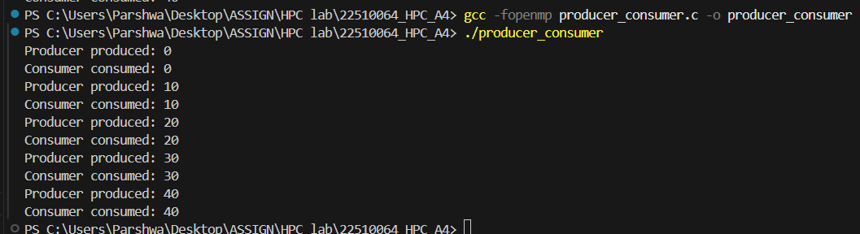

**Information:**

**Theory:**

**The Producer–Consumer problem is a classic synchronization example.**

**Producer: Generates data and stores it in a buffer.**

**Consumer: Removes data from the buffer.**

**Shared variables (buffer, count) must be accessed safely to avoid race conditions.**

**We use:**

**#pragma omp critical to ensure exclusive buffer access.**

**#pragma omp barrier to synchronize production and consumption steps.**

**Algorithm:**

**Create a buffer of fixed size SIZE.**

**Create two threads: Producer and Consumer.**

**Producer: Adds items to buffer inside a critical section, then hits a barrier.**

**Consumer: Waits at barrier, then consumes items inside a critical section.**

**Repeat until all items are produced and consumed.**